**HOMEWORK 4**

**Question No.1:**

**Describe and give a wiring diagram example of the basic principles of electrical circuit operation, how to build circuits on breadboards, and measure voltage and current at specific points in a circuit.**

**Ans:**

There are two major combinations of circuits used in designing an electronics circuit. That is series combination and parallel combination. In series combination current is same while in parallel combination voltages are same. In electronics projects and while dealing with microcontrollers, mostly the power use is small magnitude of DC. Like, voltages at trigger level/signal level. i.e.+5V DC signal from microcontroller pin output. The fundamentals of wiring diagram of electric circuit at this stage is how to connect a sensor/transducer in series and in parallel. This will clear by explaining the below circuit figure:

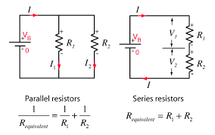

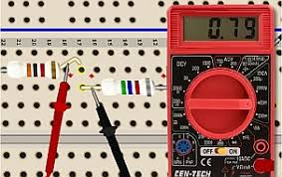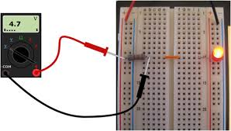The above figure shows series and parallel combination in which resistors are connected. All the circuits have a constant voltage source at one end connected with the circuit and supplying power to the circuit. The circuit is either connected in series or in parallel. The connected devices in circuit combination are may be different loads like Bulb, LED’s, TV, Refrigerator etc. While if we talk about small circuit analysis then the connected components of the circuits are resistors, capacitors and inductors. In above figure, the resistor connected in parallel are apart and their both terminals are connected with each other and then connected to source. Similarly, in series combination, one terminal of one component is connected with the one terminal of other component while the rest of the two terminals at circuit completion connects with the battery/Voltage source.

The Breadboard have power rail and terminal strip for connections. When a circuit is subject to connect on breadboard, connect circuit on breadboard by connecting in series or in parallel combination according to your circuit diagram and connect power from power rail. Once you connect the circuit like in above figures and want to measure voltages and current at specific point. Let us start from measuring the voltages of the resistor that is connected on the breadboard as shown on the above right-side picture. Calibrate your multimeter and connect its probes on both side of the resistor. The one side of resistor is connected with the power side and other is connected with ground by passing from few components. After connecting the probes across the both terminals of the resistor, the multimeter shows voltages on the display screen. Similarly in order to measure the current at specific point in the circuit, just break the circuit at that point and connect the two probes of the multimeter in series with the two break terminal of the circuit.The multimeter will show measured current on the screen as shown on the right side picture.

The below picture shows how to connect which probes either to measure voltages and current in parallel and series combinations.

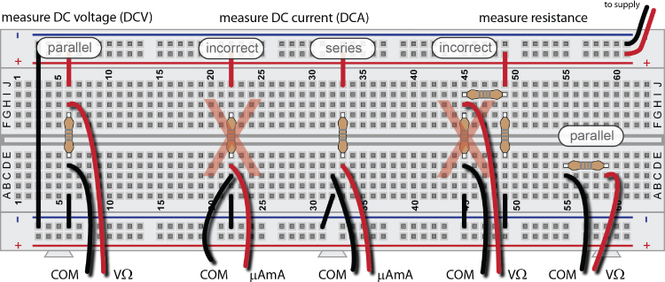

**Question No.2:**

**Describe and give a wiring diagram example how to use transistors and FETs as switches to control higher current and voltage signals than would be possible by using the RPi GPIO pins on their own.**

**Ans:**

As we know, both transistor and FET’s are used for switching purpose. Let we discuss these one by one. Starting from the transistor act as a switch. To make the transistor act as a switch connect it into common emitter configuration. For switching, the transistor either fully ON (saturated) or fully OFF (cut-off). The small leakage current flow when transistor is OFF and when transistor ON, the device has low resistance value which result in the small saturation of voltages. When the base current of the transistor reaches a threshold value the transistor become short circuit and act like ON switch. Similarly, if base voltages are under the threshold value then transistor act like an open switch (OFF).BJT are current controlling device while FETs are voltage controlling device.

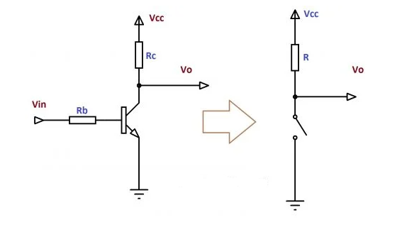

FETs are called voltage controlling device because when voltages apply between the gate and source of the FET to control the drain current. which mean FET use voltage to control the output current. When the Gate to source voltages of the FET is zero, the FET operates in saturation region and FET is in ON state which shows the current is flowing from drain to source. The positive voltages between the gate and source takes the FET is in cut-off mode so no current is flowing because FET is open circuit.

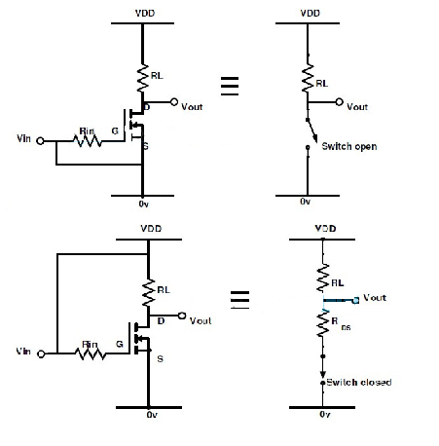

The operation of BJT and FET is mainly depending on the voltages and current of their Base/Gate terminal. Along with the current there is also one more thing which cause great effect in output voltages is operating frequency of the gate. The transistor (BJT) can operate at its maximum at 5V so the raspberry pi GPIO pins can operate BJT at its any frequency. While some FET need logic level voltages to operate while some FETs needs 9V-20V range to operate. So, in order to provide 9-20V DC to the FET gate with the same frequency as coming from the PI controller, gate driver circuit are used. The main element of Gate driver circuit is Optocoupler which amplify the voltages and current with the same frequency and duty cycle to operate FETs.

**Question No.3:**

**Describe how to interface the RPi with logic gate components and how to deal with the issues that arise with “floating” inputs.**

**Ans:**

The interfacing of the raspberry pi with the logic gates are the same as for connecting with other components. The logic gates (NOT, OR & AND) are present in the form of package (i.e. IC) in market. Every package (IC) has some number of gates. Like the AND gate require three pins. Two for input and one for output. So, Dip 14 IC package consist of 4 AND gates and remaining two pins for power and ground.

After setting up the raspberry pi, connect your circuit on the breadboard by placing IC and some output showing device like LED. As there is two input of AND gate and OR Gate. So, connect two GPIO digital pins of the raspberry pi with the gate input on the IC. Now program your pi to send pulse/signal on these two connected pins according to the truth table of the AND or OR gate. When input pulse occurs in the sequence according to the specific gate used truth table, its output is also the same as given in the truth table.

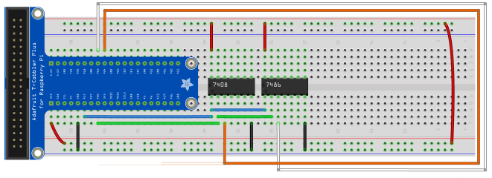

The floating inputs in case of logic gates are some bit important to avoid from false input signal and waste of input voltages and leakage current flowing .While designing the logic gate circuit, if we are going to use only one gate present in the IC then the other three gates present on the IC remain unused and their inputs are open and not connected with any terminal. So, the leakage of current may occur and these inputs cause errors in the output of other gates. So, in order to overcome this problem, we have to connect these unused logic gates terminal with power side or ground side. Or this problem can be overcome by using pull-up or pull-down resistors depend on the input state. These attached resistance on input side of the logic gates stop the leakage of current which cause them to remain stable.

**Question No.4:**

**Describe the principles and give a wiring diagram example of analog-to-digital conversion.**

**Ans:**

Analog to digital conversion (ADC) is the process of conversion of real-world signal (i.e. temperature, light, current, distance etc.) into a digital signal. The analog signal has to passes from two process while converting from analog to digital signal. These are sampling and quantization processes. For sampling process sampling rate and sampling resolution must be taken in notice to set according to the desired parameters. The sampling of signal is the reduction of a continuous -time signal to discrete time signal. While quantization is the process of mapping input values from a large set to output values in a smaller set mostly with a finite number of elements. For converting an analog signal into digital signal, first analog signal is sampled at specific sampling rate. The sampling resolution must be kept in notice and set according to demand. After sampling the quantization process occurs. Quantization process is the process of replacing each real number with an approximation from a finite set of discrete values.

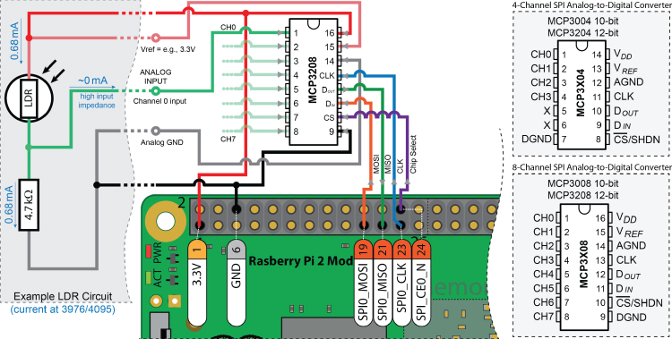

Look on above picture, you can see LDR is an analog sensor and give its output also an analog signal. To make you controller to read analog signal we have to first convert this signal into digital signal. Some controllers have already built-in this feature. The ADC module convert analog signal into digital and the controller can easily read this signal.

**Question No.5:**

**Describe the problem of mechanical switch bouncing. Give four solutions for dealing with switch bouncing, including wiring diagrams or software pseudocode.**

**Ans:**Switches are most commonly used device in electronics circuit and electrical panels. The switched are of different forms: toggle switch, push buttons, joystick, selector switch etc. Some switches are SPST (single pole single throw) while some or SPDT (single pole doble throw). In both of the switches some problems are common in which one is mechanical bouncing of switch. This bouncing creates problems when switches are connected with the microprocessor. Actually, switch bouncing sends the same input two-three time more as compare to simple switch toggling so the controller input misguides by the switch and become the result of false output. The bouncing causes the switch to repeatedly bounce from the contact on impact. No doubt the switch bounce for very less time duration (for milliseconds) but it can send false input to the controller which result in false output.

The problem of switch bouncing is overcome by some different ways:

**Use of low pass filter:** The use of low pass filter stops the low frequency/magnitude pulses and send only the main/single pulse to the controller output. so the controller did not puzzle between different inputs at same pin.

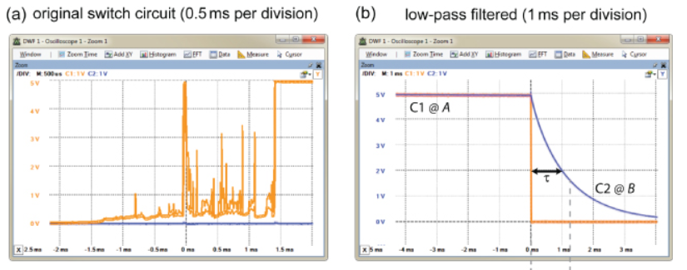

**By making software (code):** This problem can be overcome by writing a code in raspberry pi such that the circuit is ON or take input from the switch with time delay of some seconds.Like the system read switch input after 3s of pressing switch.

**S-R Latch:** if the switch used is slider switch. So to overcome this switching bouncing use S-R latch.

**Hysteresis:** Hysteresis is used to avoid rapid switching when switch is pressed. A Schmitt trigger shows hysteresis which shows that output is dependent of input and also the previous inputs.

